**IoT in Energy**

The Internet of Things (IoT) is revolutionizing the energy sector by enabling real-time data collection, communication, and control of energy systems. This is leading to more efficient, sustainable, and resilient energy infrastructure.

**Smart Grids:** Smart grids are one of the most important applications of IoT in energy. Smart grids use IoT sensors and devices to collect data on energy consumption, grid conditions, and weather patterns. This data is then used to optimize energy distribution, reduce outages, and integrate renewable energy sources.

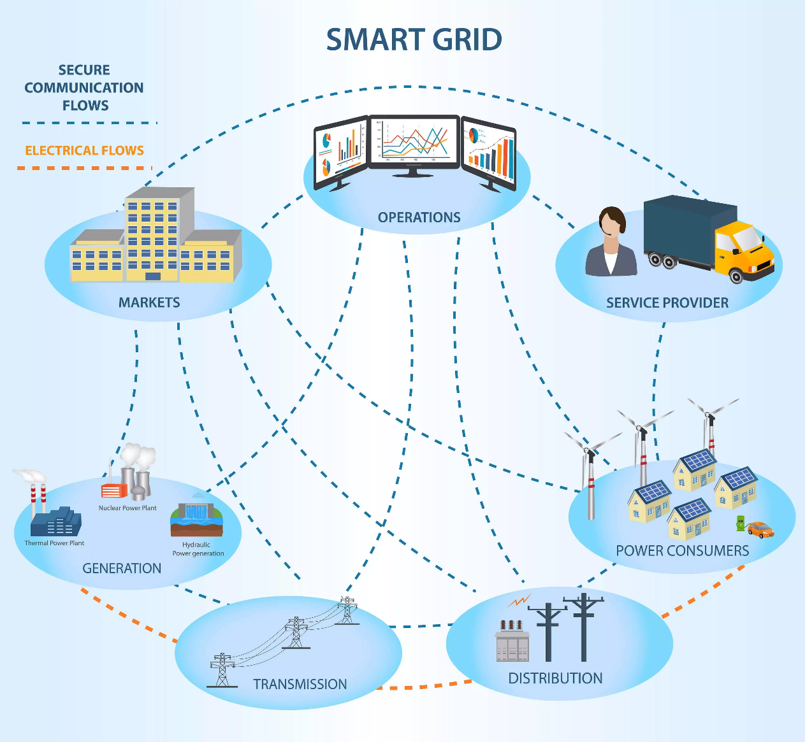

**Grid Monitoring and Control:** IoT sensors placed throughout the power grid provide real-time data on energy consumption, voltage levels, and equipment health. This allows for efficient grid management, quicker response to faults, and optimal distribution of electricity.

**Renewable Energy Management:** Renewable energy integration is another area where IoT is playing a major role. IoT sensors and devices are being used to monitor and control renewable energy sources, such as solar and wind power. This is helping to integrate these sources into the grid more efficiently and reliably.

Solar and Wind Farms: IoT devices are used to monitor and control solar panels and wind turbines. Data on energy production, weather conditions, and equipment status help optimize energy output and plan maintenance schedules.

**Energy Consumption Monitoring:**

Smart Meters: Smart meters allow consumers to track their energy usage in real time, which can help them identify areas where they can save energy. Smart meters can also be used to implement demand response programs, which allow utilities to incentivize consumers to reduce their energy consumption during peak periods. IoT-enabled smart meters allow for accurate monitoring of energy consumption in real-time. This data helps consumers and utility companies understand usage patterns, facilitating better energy management and billing accuracy.

**Demand Response:** Demand response is another area where IoT is being used. IoT devices can be used to control energy consumption in homes and businesses, based on real-time data on grid conditions and energy prices. During peak demand periods, smart devices can adjust their energy usage based on signals from the grid, helping to balance supply and demand. This can help to reduce peak demand and save money for consumers and utilities.

**Predictive Maintenance:** Predictive maintenance is also being improved with IoT. IoT sensors can be used to monitor the health of energy equipment, such as transformers and turbines. This data can then be used to predict when equipment is likely to fail, so that maintenance can be scheduled in advance. This can help to reduce downtime and improve the reliability of the energy grid.

Equipment Health Monitoring: IoT sensors on power generation and distribution equipment collect data on performance and condition. Machine learning algorithms can predict potential failures, allowing for proactive maintenance and reducing downtime.

**Energy Conservation in Buildings:** IoT is also being used to improve the efficiency of energy consumption in buildings. IoT sensors can be used to monitor lighting, heating, and cooling systems, and to control these systems based on occupancy and other factors. This can help to reduce energy consumption and save money.

Smart HVAC Systems: IoT sensors in heating, ventilation, and air conditioning (HVAC) systems optimize energy consumption based on occupancy, external weather conditions, and user preferences.

Lighting Control: Smart lighting systems use IoT to adjust brightness and color temperature based on natural light and occupancy, saving energy.

**Electric Vehicles (EVs) and Charging Infrastructure:**

Smart Charging Stations: IoT is utilized in EV charging infrastructure to manage charging schedules, monitor energy demand, and optimize charging based on grid conditions.

Vehicle-to-Grid (V2G) Integration: IoT enables bidirectional communication between EVs and the grid, allowing electric vehicles to feed excess energy back into the grid during peak demand.

**Energy Trading and Blockchain:**

Decentralized Energy Markets: IoT, combined with blockchain technology, enables peer-to-peer energy trading. Smart contracts facilitate secure and transparent transactions between energy producers and consumers.

**Environmental Monitoring:**

Air Quality Monitoring: IoT devices can monitor environmental parameters, such as air quality and emissions, providing valuable data for sustainable energy practices and policy-making.

## Using Internet of Things in smart grid

The role of IoT in smart grid is crucial. Internet of Things is in large part the enabler of smart grid as its technological and infrastructural components are largely IoT-based.

### Connected devices, appliances, hubs: The data on energy consumption comes from sensor-enabled IoT devices, appliances and hubs that control a smart house or any other connected space. This data is then used to analyze electricity usage, calculate the cost, remotely control appliances, make decisions on load distribution, detect malfunctions.

**IoT-based process automation:** Smart grid IoT technology is widely used to automate processes and increase efficiency in the supply chain. Producers and destributers:

* Adopt automated metering to monitor energy usage in real-time and dynamically respond to changing demand.
* Use environmental data and [IoT technologies in renewable energy](https://www.digiteum.com/build-software-renewable-energy/) to optimize power production and maximize the use of green sources of energy.
* Monitor grid load and adopt data-driven strategy to minimize the risks of outages or overloads.

**Predictive maintenance:** Predictive maintenance is one of the most important use cases for smart grid IoT applications for power plants, energy distributors and utilities. Operations on the upstream and downstream sides are built on the use of expensive equipment and infrastructure. Using intelligent grid technology for monitoring and energy grid management allows stakeholders to better control their assets, predict wear or malfunction and implement timely maintenance.

**Real-time data analytics and visualization:** As mentioned above, the role of big data in smart grid operation is very significant. Thanks to processing, sorting, cleaning, [analysis and visualization of IoT data](https://www.digiteum.com/data-visualization-your-business/), stakeholders gain important insights about the processes in the supply chain from the moment the energy is produced to the point it is consumed by an end-user. Big data applications enable automation, management, problem detection and prediction in a smart energy grid.

**Advanced algorithms:** Applications based on machine learning are already common in the IoT market, and IoT smart energy grid is not an exception. We know for a fact that machine learning is good at working with massive datum sets. It helps better understand and use big data, identify trends, make predictions. Therefore, the use of advanced algorithms to analyze IoT data created in the smart grid supply chain is another way to make it more efficient.

**Innovative smart grid technologies:** The operation of smart grid relies on a broad range of technology and infrastructure solutions. Smart grid based on IoT and data technologies is prevailing and includes several important components:

* **Smart grid sensors and meters.**The role of sensor technology is very important because these are the components that help track energy consumption on the consumer side. Sensors in smart appliances continuously create and report status data to enable monitoring and control. Smart meters collect energy use data and show the full picture of energy consumption in the house, including loads and estimated cost.
* **Automated distribution.**Advanced distribution systems use real-time data to dynamically respond to the changes in load, detect overload and correct power distribution to enable both safety and economic savings. This is an example of how a smart grid using IoT enables automation.
* **Charging stations and smart storage.** The role of energy storage and charging stations in continuously increasing. Not only do these technologies allow households to safely go off-grid in cases of outages or accidents. They also reflect the growing demand for independent residential renewable systems.

**IoT applications in smart grid:** Here are some successful examples of the use of IoT in smart grid, from the national level to startup solutions for households.

* Germany has integrated IoT infrastructure and technology solutions to implement a smart grid project in Mannheim. This project enabled the broad adoption of renewable energy and allowed to coordinate energy consumption and production in the city.
* [Lumin energy management platform](https://www.luminsmart.com/) is a good example of IoT application in smart grid which enables cost savings, reduced emissions and easier adoption of green energy at the same time. The company offers a smart panel and data analytics tools to optimize storage, manage electricity consumption and facilitate the integration of PV systems in houses.
* [Schneider Electric offers a set of connected solutions](https://solar.schneider-electric.com/solutions/residential/) for implementing solar power for homes. The company can equip a household with PV systems, monitoring and management tools to go fully off-grid or generate and convert solar energy to partially cover the household’s demand.
* Cisco is one of the leaders among Internet of Things smart grid enablers. The company together with several partners helps different players on the upstream and downstream side to bring in connected technology and enhance grid operations. Among their success stories is the modernization of [BC Hydro](https://www.cisco.com/c/dam/en_us/solutions/industries/energy/downloads/bc-hydro-cisco.pdf). Cisco helped the utility provider increase efficiency and reliability using smart metering and advanced analytics technologies.
* Siemens has a large share of solutions for smart grid in IoT portfolio. The company offers a range of software and infrastructure solutions for energy intelligence. One of their clients, a German electrical wholesaler [Rexel](https://new.siemens.com/global/en/company/stories/infrastructure/2018/rexel-energy-management-mindsphere.html/), implemented a large retrofit project and integrated a power monitoring system by Siemens for energy metering and analytics.

**Challenges and Considerations:**

* Security: Given the critical nature of energy infrastructure, ensuring the security of IoT devices and networks is paramount.
* Interoperability: Standardization is crucial to ensure seamless communication and interoperability among diverse IoT devices in the energy ecosystem.

The use of IoT in energy is still in its early stages, but it has the potential to revolutionize the way we generate, distribute, and consume energy. IoT is helping to make the energy sector more efficient, sustainable, and resilient, and it is opening up new opportunities for innovation.

**Sample questions:**

**Remembering**

1. What are some of the main benefits of using IoT in the energy sector?
2. Can you name a few examples of IoT-enabled energy applications?
3. How does IoT contribute to improving energy efficiency and sustainability in the energy sector?

**Understanding**

1. Explain how IoT sensors can be used to monitor and manage energy consumption in smart grids.
2. Describe how IoT-enabled smart meters can provide real-time energy usage data to consumers.
3. Discuss the role of IoT in enhancing renewable energy integration and grid stability.

**Applying**

1. Design an IoT-based predictive maintenance system for wind turbines to optimize performance and reduce downtime.
2. Propose an IoT-enabled demand response program that incentivizes consumers to shift their energy usage during peak periods.
3. Develop an IoT-driven smart lighting system for industrial facilities to optimize lighting schedules and reduce energy consumption.

**Analyzing**

1. Evaluate the impact of IoT on greenhouse gas emissions and climate change mitigation efforts in the energy sector.
2. Assess the potential challenges and security concerns associated with the deployment of IoT in energy infrastructure.
3. Analyze the role of data analytics and machine learning in extracting insights from IoT data to optimize energy production, distribution, and consumption.

**Creating**

1. Design a prototype for an IoT-enabled smart grid monitoring system that utilizes sensors and real-time data analytics to detect and respond to anomalies.
2. Develop a conceptual framework for an IoT-based energy trading platform that facilitates peer-to-peer energy transactions among consumers.
3. Create a proposal for an IoT-driven energy efficiency program that targets specific energy-intensive industries or sectors.

**Evaluating**

1. Critically evaluate the effectiveness of IoT-enabled energy applications in reducing energy costs and improving energy efficiency.
2. Assess the ethical implications of using IoT data in energy policy and decision-making processes.
3. Evaluate the scalability and adaptability of IoT solutions in response to evolving energy demands and technological advancements in the energy sector.